**Pass Task 8**

Pigeon Table

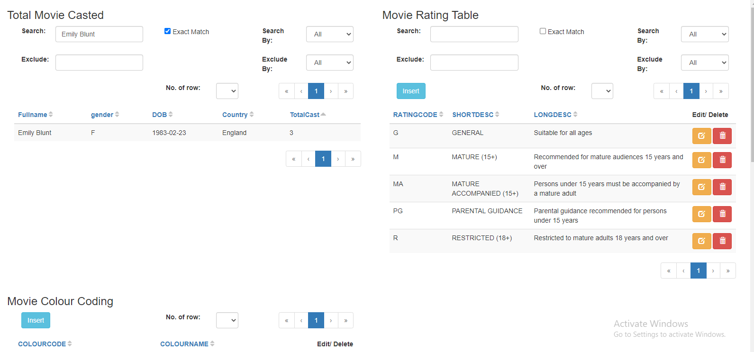

Figure 1: Search using Exact Match

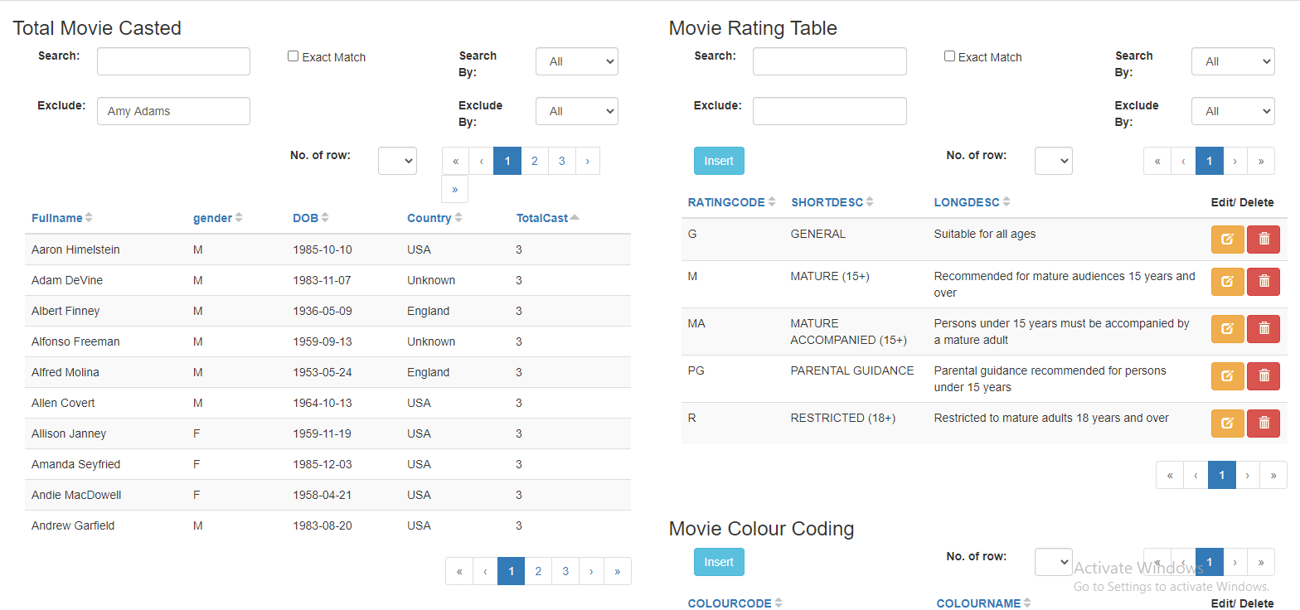

Figure 2: Excluding Amy Adams

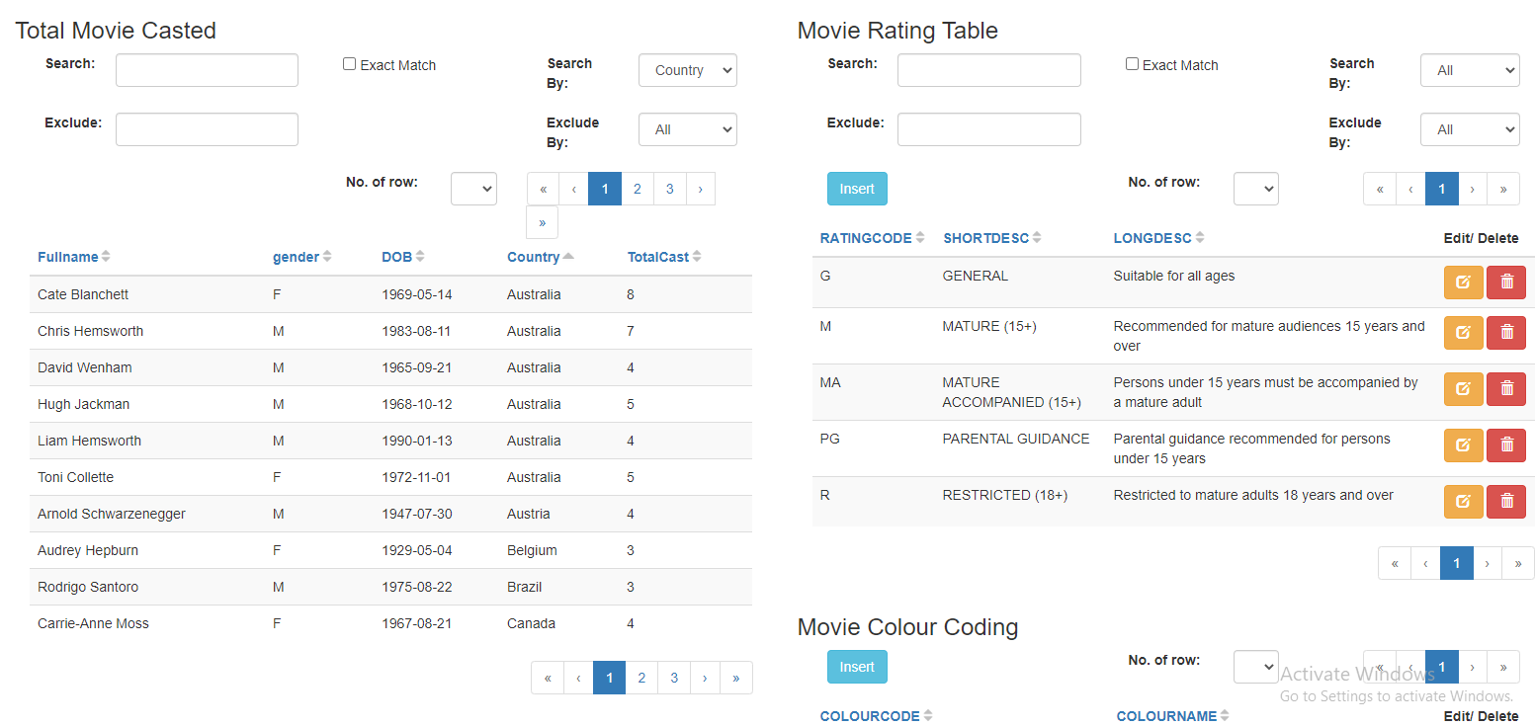

Figure 3: Sorting by Country

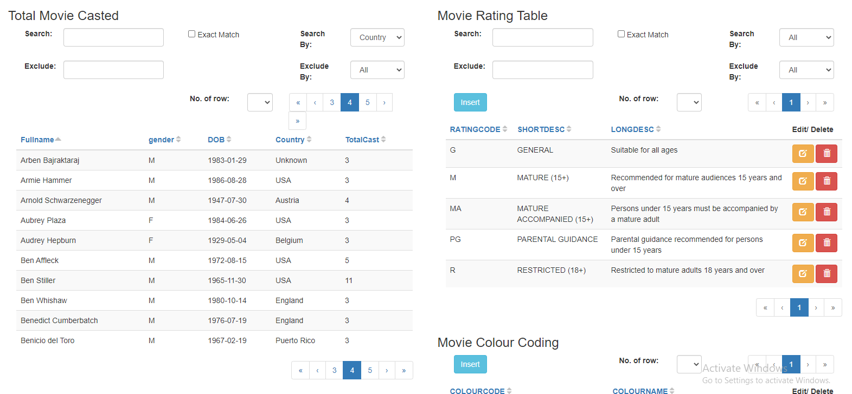

Figure 4: Using the Pagination Feature

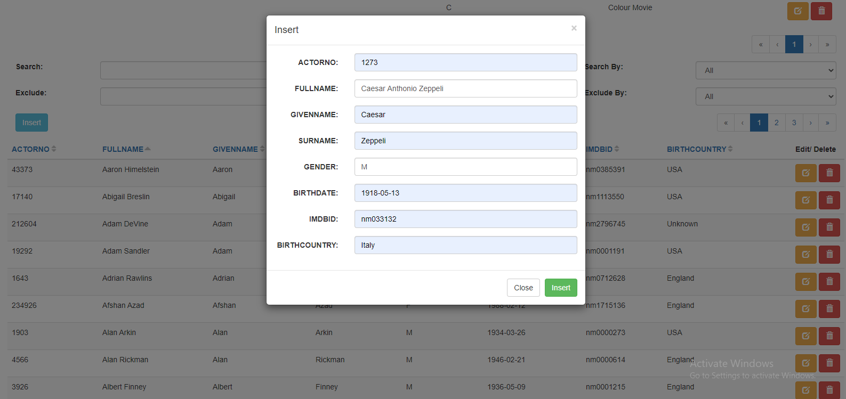

Figure 5: Inserting data into table

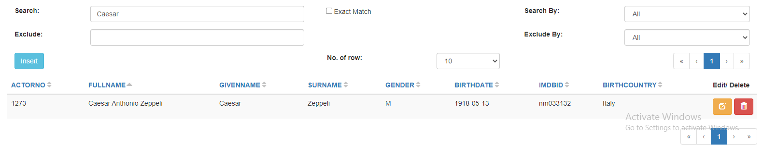

Figure 6: Caesar is there

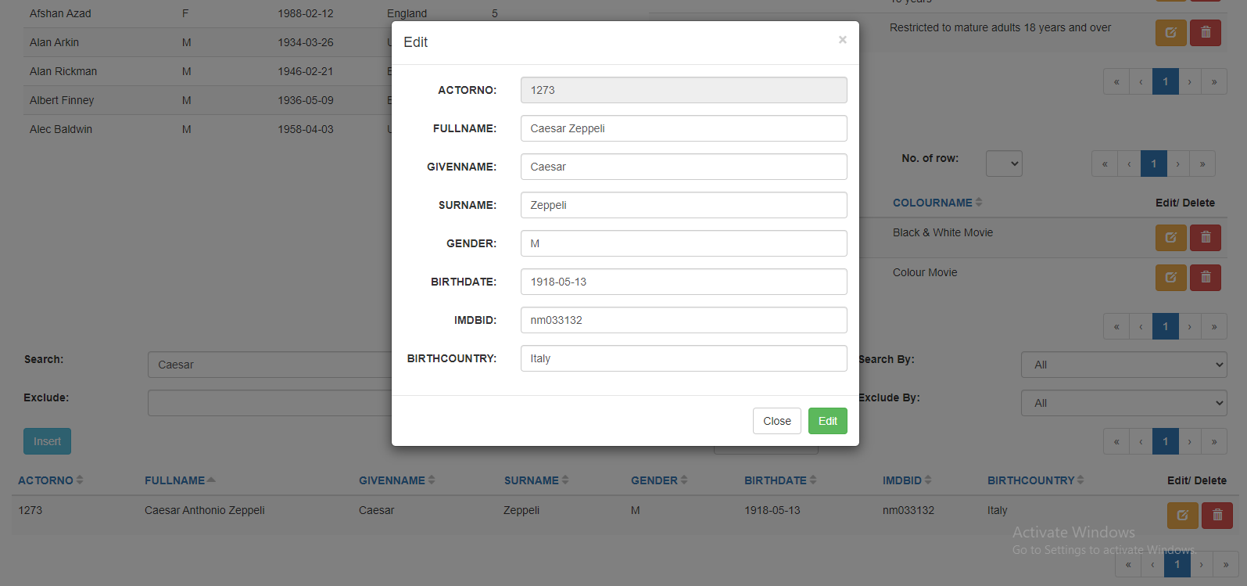

Figure 7: Editing data in table

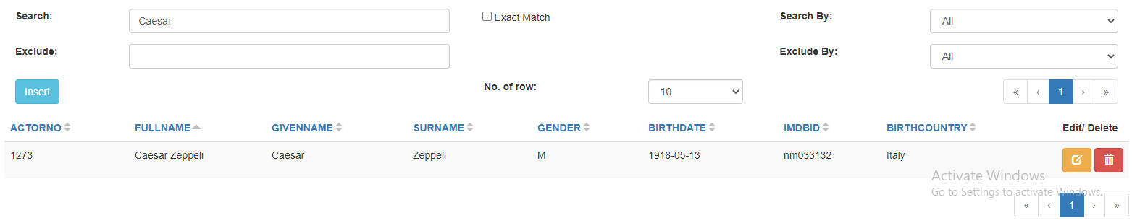

Figure 8: Caesar changed his name!

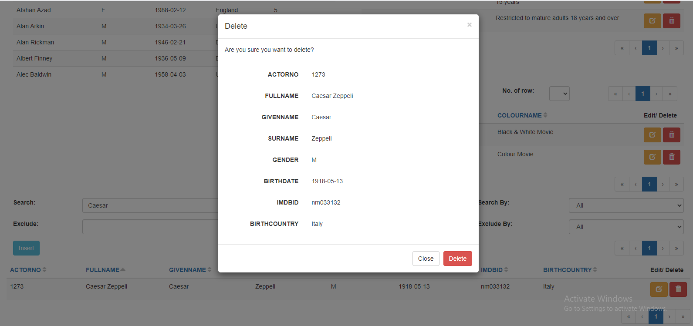

Figure 9: Deleting data in table

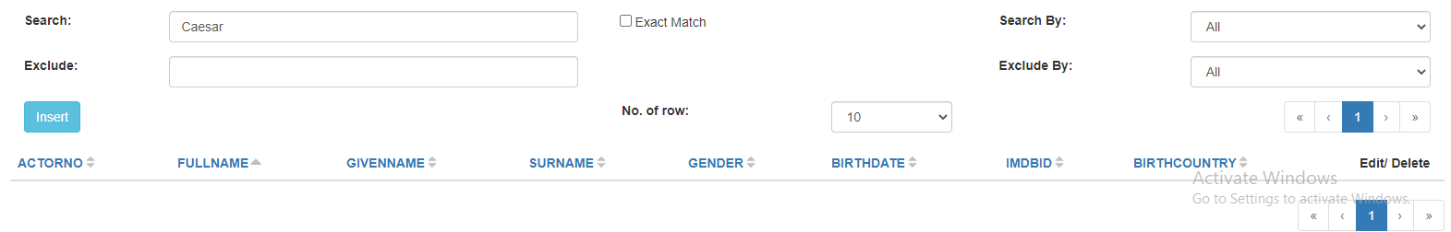

Figure 10: CAAAAAAEEEEEESSSSSSAAAAAAARRRRRRRR!!!!!!!!!

Pigeon Chart

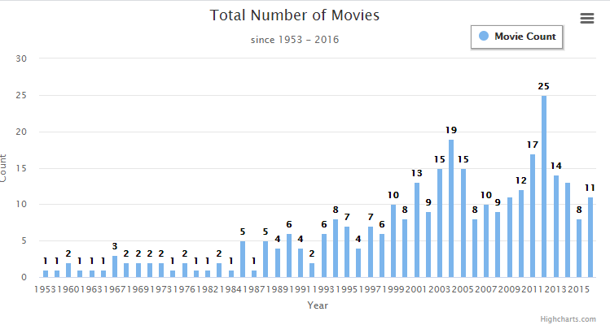

Figure 11: Basic bar char with normal elements

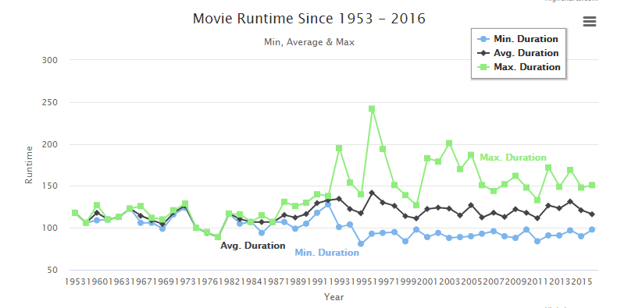

Figure 12: Multi-series line chart

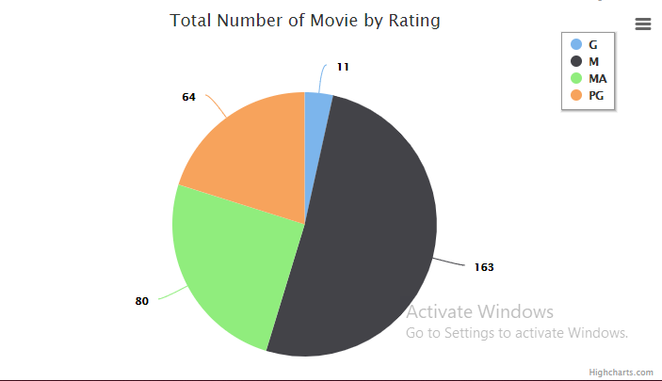

Figure 13: Pie chart

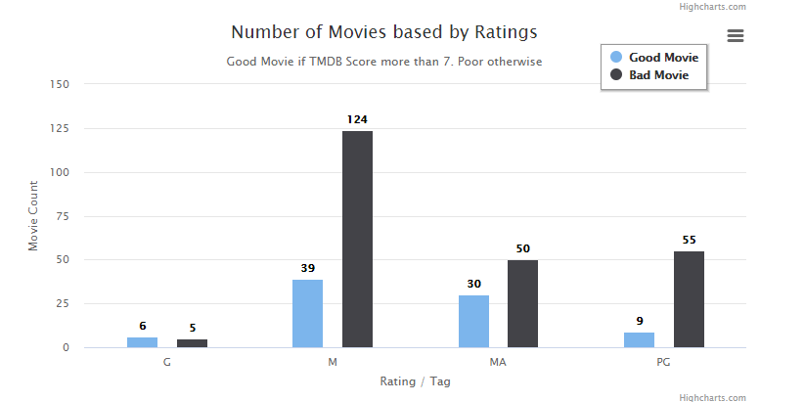

Figure 14: Comparison bar chart

Feedback

In my opinion, this framework is nice. Using this framework can allow a web developer to easily visualise data from databases into tables or charts. One can create a table with options to insert, edit, or delete data from a table by just adding an attribute when creating the pigeon table. In other words, one doesn’t have to manually add button elements and link them to a script or action that manipulates data in the database. One can also retrieve data from the database by using SQL queries directly in the pigeon table element, which is amazing. For charts, it is also the same case with using queries. One can also visualise data and set their respective chart elements like legends or titles in the pigeon chart itself. This makes things easier for web developers who want to visualise data on a web page.

However, there is a thing that I’m concerned about, which is does this framework support other types of querying languages other than SQL? There are many querying languages out there, and even though SQL is used by a vast majority of web developers, it would be nice to know that this framework also supports other querying languages as well.